Digital Technologies & Hangarau Matihiko 3.1

Level 3, 3 Credits, Internal Assessment

Design Feedback Document

This document serves as evidence of feedback of your mock-ups that include **font combinations** and **colour schemes**

Table of Contents

Mock-up 1 2

Colour Scheme, Font Combination & Adobe XD Mock-Up 2

Colour Scheme, Font Combination, Mock-Up & General Feedback 3

Pros of the Mock-Up 4

Improvements to the Mock-Up 4

Other Feedback 4

Mock-up 2 5

Colour Scheme, Font Combination & Adobe XD Mock-Up 5

Colour Scheme, Font Combination, Mock-Up & General Feedback 6

Pros of the Mock-Up 7

Improvements to the Mock-Up 7

Other Feedback 7

Mock-up 3 8

Colour Scheme, Font Combination & Adobe XD Mock-Up 8

Colour Scheme, Font Combination, Mock-Up & General Feedback 9

Pros of the Mock-Up 10

Improvements to the Mock-Up 10

Other Feedback 10

Review 11

Preferred Mock-Up 11

Why did you prefer it? 11

Suggestions to improve the Mock-Up 11

# Mock-up 1

## Colour Scheme

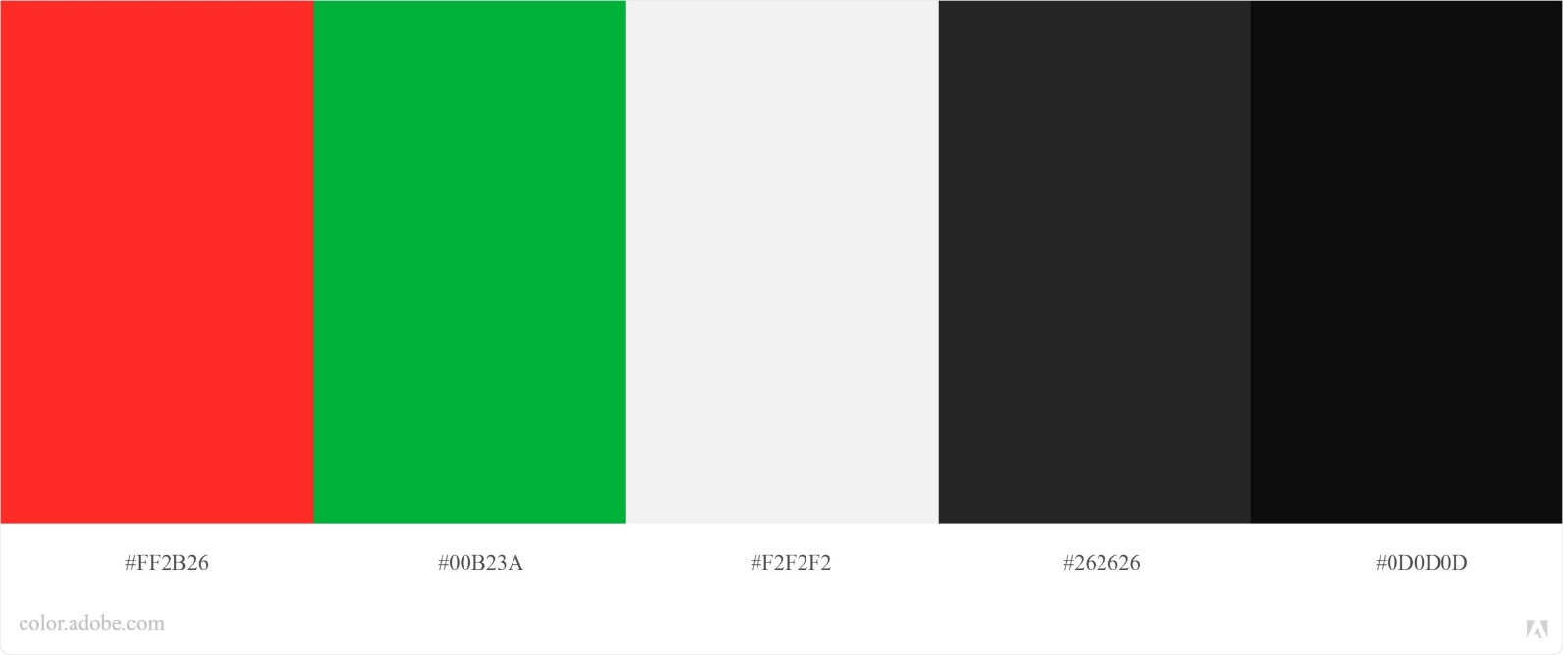

## Font Combination

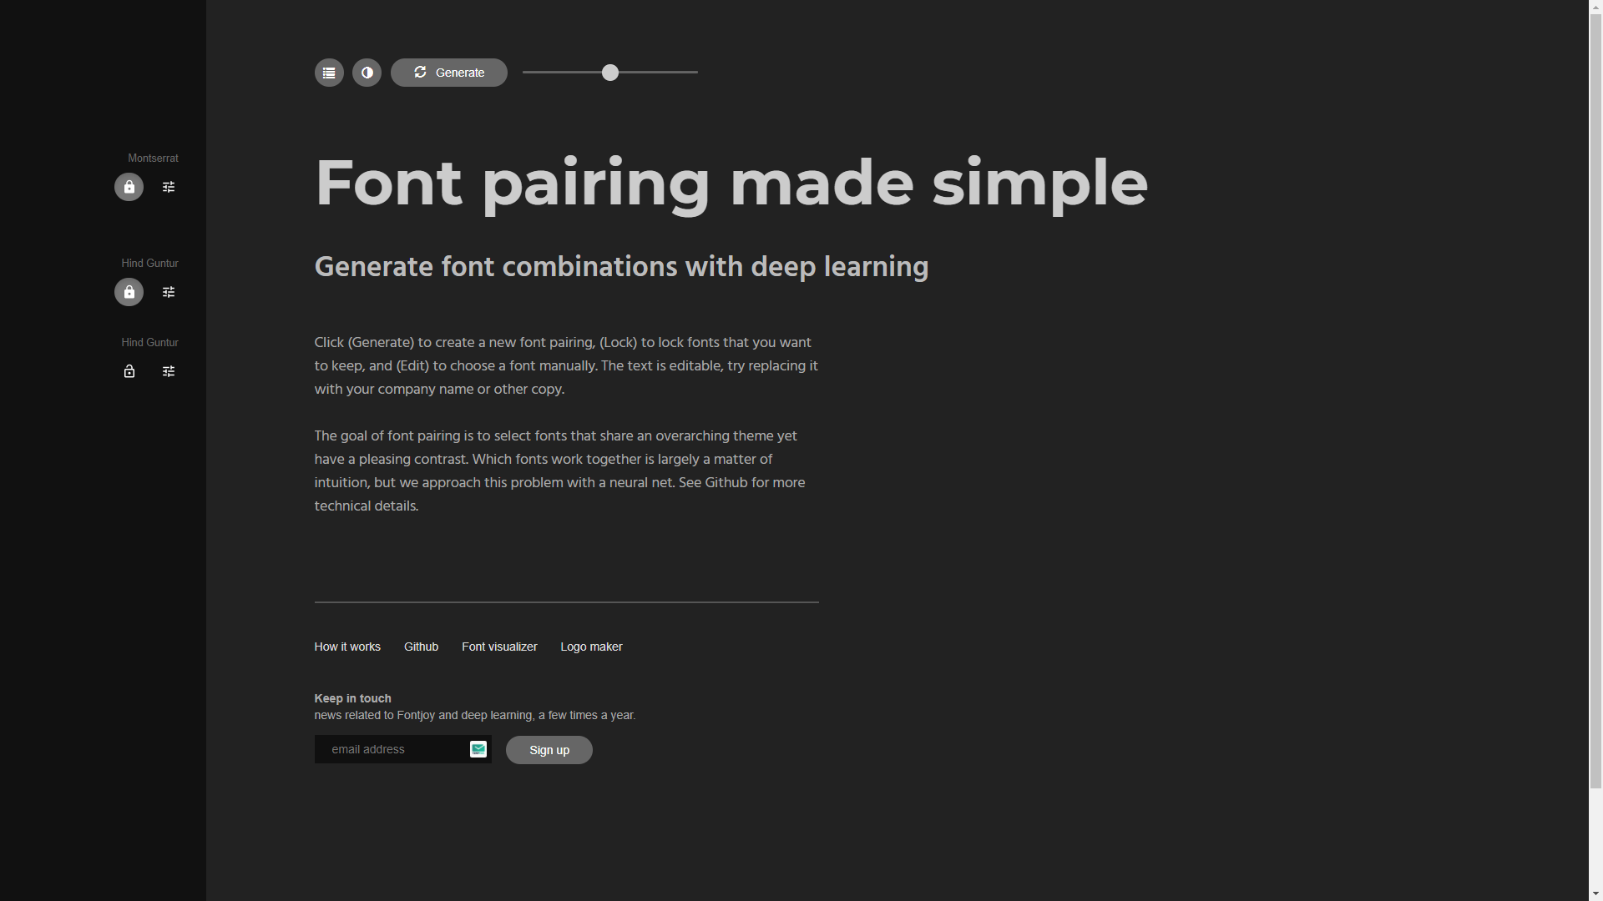

## Adobe XD Mock-Up

## Colour Scheme Feedback

Circle/highlight the words that come to mind when you look at the **colour** scheme

|  |  |  |  |  |  |
| --- | --- | --- | --- | --- | --- |
| Professional | Warm | Childish | Simple | Shambolic | Relaxed |
| Overbearing | Casual | Engaging | Clever | Serious | Cold |
| Sloppy | Trustworthy | Playful | Interesting | Easy | Arrogant |
| Inclusive | Sleek | Detailed | Confident | Chilled | Clinical |
| Authoritative | Exciting | Open | Laid back | Fun | Amateur |
| Supportive | Stuffy | Silly | Helpful | Enthusiastic | Bossy |

## Font Combination Feedback

Circle/highlight the words that come to mind when you look at the **font** combination

|  |  |  |  |  |  |
| --- | --- | --- | --- | --- | --- |
| Professional | Warm | Childish | Simple | Shambolic | Relaxed |
| Overbearing | Casual | Engaging | Clever | Serious | Cold |
| Sloppy | Trustworthy | Playful | Interesting | Easy | Arrogant |
| Inclusive | Sleek | Detailed | Confident | Chilled | Clinical |
| Authoritative | Exciting | Open | Laid back | Fun | Amateur |
| Supportive | Stuffy | Silly | Clean | Enthusiastic | Bossy |

## Mock-up Feedback

Are there any other words that you associate with this mock-up?

|  |
| --- |
| Predominantly Sans Fonts, Clear to the visually impaired |

## General Feedback

What do you think about the choice of:

|  |  |
| --- | --- |
| **Background colour** | White: Bland but could be pulled off in a professional way |
| **Text colours** | Standard website colours |
| **Text-on-background combo** | Currently the contrast looks to be fine, |
| **Accent colours** | Interesting, need to consider where it is appropriate, aesthetics wise, for the accent colour to be used |

Circle/highlight any statements you find applicable:

|  |  |  |
| --- | --- | --- |
| The **colours** in the mock-up make text hard to read | The **colours** in the mock-up make it hard to see where I need to interact (click, tap, type, etc.) | The **colours** in the mock-up make it hard to distinguish different sections |
| The **fonts** (including typeface, size, spacing, etc.) in the mock-up make text hard to read | The **fonts** (including typeface, size, spacing, etc.) in the mock-up make it hard to see where I need to interact (click, tap, type, etc.) | The **fonts** (including typeface, size, spacing, etc.) in the mock-up make it hard to distinguish different sections |
| I have not found anything in the mock-up that makes text hard to read | I have not found anything in the mock-up that makes it hard to see where I need to interact | I have not found anything in the mock-up that makes it hard to distinguish different sections |

## Pros of the Mock-Up

The mock-ups for the quiz screens (multi-choice & text box answers) look very clean, no clutter and the essential buttons are clearly visible. I’d assume that there would be no scrolling on these pages either so that eliminates the possibility for the user to miss a button that’s below the visible screen

## Improvements to the Mock-Up

I think that the quiz selection cards will need to go through a fair amount of iterative development, although they are not shocking they also look like they are at an amateur standard

I also think that the colour schemes accent colours should also go through some iterative development. In my opinion, the accent colours are too vibrant which would be fine for something like a question indicator (telling the user weather they answered correctly or not)

## Other Feedback

Bar the development needed for some of your components I don’t have anything else to say for this mock-up

# Mock-up 2

## Colour Scheme

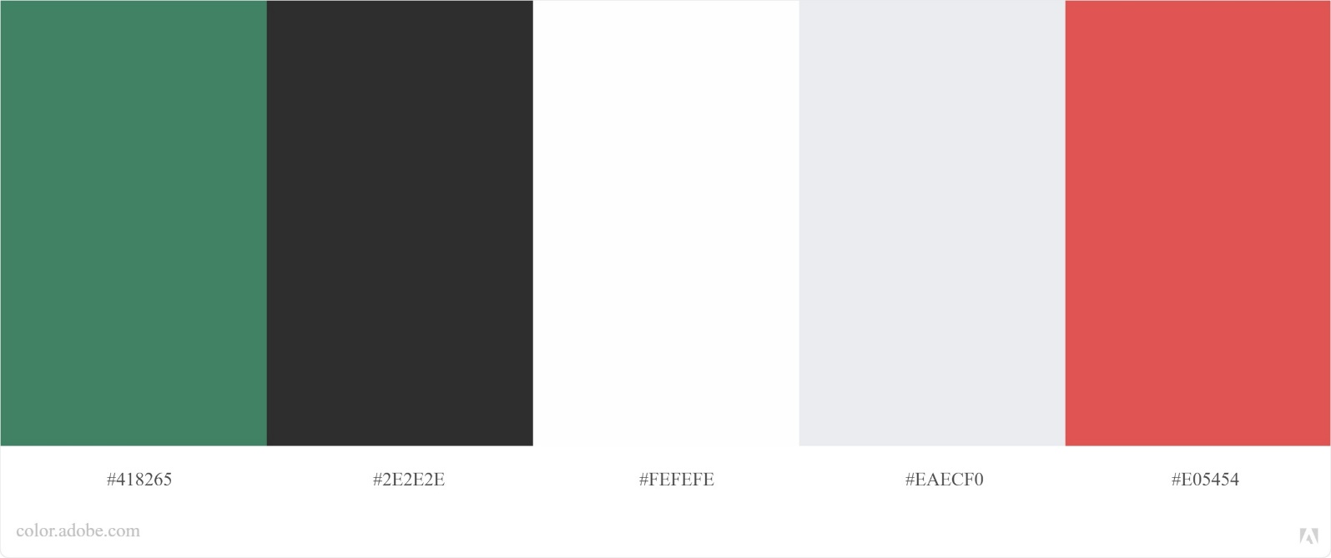

## Font Combination

## Adobe XD Mock-Up

## Colour Scheme Feedback

Circle/highlight the words that come to mind when you look at the **colour** scheme

|  |  |  |  |  |  |
| --- | --- | --- | --- | --- | --- |
| Professional | Warm | Childish | Simple | Shambolic | Relaxed |
| Overbearing | Casual | Engaging | Clever | Serious | Cold |
| Sloppy | Trustworthy | Playful | Interesting | Easy | Arrogant |
| Inclusive | Sleek | Detailed | Confident | Chilled | Clinical |
| Authoritative | Exciting | Open | Laid back | Fun | Amateur |
| Supportive | Stuffy | Silly | Helpful | Enthusiastic | Bossy |

## Font Combination Feedback

Circle/highlight the words that come to mind when you look at the **font** combination

|  |  |  |  |  |  |
| --- | --- | --- | --- | --- | --- |
| Professional | Warm | Childish | Simple | Shambolic | Relaxed |
| Overbearing | Casual | Engaging | Clever | Serious | Cold |
| Sloppy | Trustworthy | Playful | Interesting | Easy | Arrogant |
| Inclusive | Sleek | Detailed | Confident | Chilled | Clinical |
| Authoritative | Exciting | Open | Laid back | Fun | Amateur |
| Supportive | Stuffy | Silly | Helpful | Enthusiastic | Bossy |

## Mock-up Feedback

Are there any other words that you associate with this mock-up?

|  |
| --- |
| Variation of font styles |

## General Feedback

What do you think about the choice of:

|  |  |
| --- | --- |
| **Background colour** | Once again quite a bog standard white colour |
| **Text colours** | Standard website colours |
| **Text-on-background combo** | Appears to be fine, but check using a contrast checker |
| **Accent colours** | Accent colours fir the theme much better than the other colour scheme. All the colours here are of a matte shade which fits consistency |

Circle/highlight any statements you find applicable:

|  |  |  |
| --- | --- | --- |
| The **colours** in the mock-up make text hard to read | The **colours** in the mock-up make it hard to see where I need to interact (click, tap, type, etc.) | The **colours** in the mock-up make it hard to distinguish different sections |
| The **fonts** (including typeface, size, spacing, etc.) in the mock-up make text hard to read ***(only in certain places)*** | The **fonts** (including typeface, size, spacing, etc.) in the mock-up make it hard to see where I need to interact (click, tap, type, etc.) | The **fonts** (including typeface, size, spacing, etc.) in the mock-up make it hard to distinguish different sections |
| I have not found anything in the mock-up that makes text hard to read | I have not found anything in the mock-up that makes it hard to see where I need to interact | I have not found anything in the mock-up that makes it hard to distinguish different sections |

## Pros of the Mock-Up

I really like how the lesson select has an image and the lesson names clearly standout

## Improvements to the Mock-Up

I would suggest including some nice cartoonish icons or illustrations nest to the lesson cards that could be associated with it. Doing this could bring a good professional look to your website if you can find a way to source and incorporate them as well.

## Other Feedback

I do not think that there is much more you can do to develop the quiz questions pages, other than showing the user system status like correct/incorrect answers or showing letting the user know that they need to provide an answer.

# Mock-up 3

## Colour Scheme

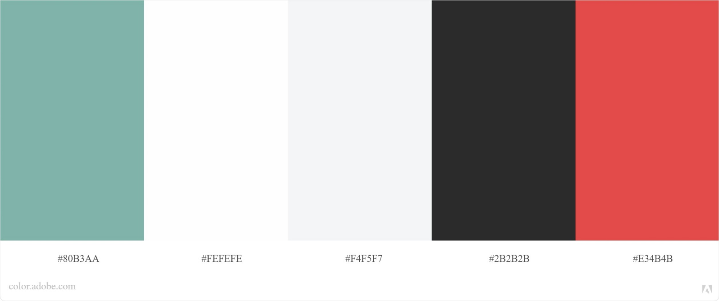

## Font Combination

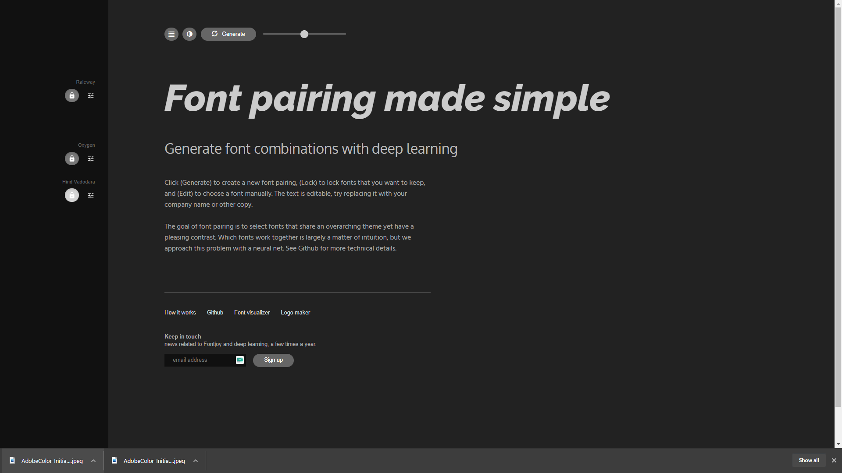

## Adobe XD Mock-Up

## Colour Scheme Feedback

Circle/highlight the words that come to mind when you look at the **colour** scheme

|  |  |  |  |  |  |
| --- | --- | --- | --- | --- | --- |
| Professional | Warm | Childish | Simple | Shambolic | Relaxed |
| Overbearing | Casual | Engaging | Clever | Serious | Cold |
| Sloppy | Trustworthy | Playful | Interesting | Easy | Arrogant |
| Inclusive | Sleek | Detailed | Confident | Chilled | Clinical |
| Authoritative | Exciting | Open | Laid back | Fun | Amateur |
| Supportive | Stuffy | Silly | Helpful | Enthusiastic | Bossy |

## Font Combination Feedback

Circle/highlight the words that come to mind when you look at the **font** combination

|  |  |  |  |  |  |
| --- | --- | --- | --- | --- | --- |
| Professional | Warm | Childish | Simple | Shambolic | Relaxed |
| Overbearing | Casual | Engaging | Clever | Serious | Cold |
| Sloppy | Trustworthy | Playful | Interesting | Easy | Arrogant |
| Inclusive | Sleek | Detailed | Confident | Chilled | Clinical |
| Authoritative | Exciting | Open | Laid back | Fun | Amateur |
| Supportive | Stuffy | Silly | Helpful | Enthusiastic | Bossy |

## Mock-up Feedback

Are there any other words that you associate with this mock-up?

|  |
| --- |
| Inviting |

## General Feedback

What do you think about the choice of:

|  |  |
| --- | --- |
| **Background colour** | Standard white colour |
| **Text colours** | Fits the Onslow Collage theme making the site look park of the collage |
| **Text-on-background combo** | Appears to be fine, but check using a contrast checker |
| **Accent colours** | Accent colours fit in with the Onslow College colours making them a good choice for a website associated with the collage |

Circle/highlight any statements you find applicable:

|  |  |  |
| --- | --- | --- |
| The **colours** in the mock-up make text hard to read | The **colours** in the mock-up make it hard to see where I need to interact (click, tap, type, etc.) | The **colours** in the mock-up make it hard to distinguish different sections |
| The **fonts** (including typeface, size, spacing, etc.) in the mock-up make text hard to read ***(only in certain places)*** | The **fonts** (including typeface, size, spacing, etc.) in the mock-up make it hard to see where I need to interact (click, tap, type, etc.) | The **fonts** (including typeface, size, spacing, etc.) in the mock-up make it hard to distinguish different sections |
| I have not found anything in the mock-up that makes text hard to read | I have not found anything in the mock-up that makes it hard to see where I need to interact | I have not found anything in the mock-up that makes it hard to distinguish different sections |

## Pros of the Mock-Up

I really like how the quiz question pages look. They are not too busy and guide the users attention right to wards the questions and answer box/answer making for a perfectly designed page. Keep these pages in the final design.

## Improvements to the Mock-Up

If I were to suggest something, I’d suggest giving the website background. Using one of those blurry neutral glassy backgrounds in order to provide a wee bit of depth without overwhelming the user. would be a good addition as to stop the website from looking too bland. Do not use this unless you can make it look professional, however.

## Other Feedback

I do not like the look of the red gradient background used on the lessons page. Rather keep it a solid colour.

# Review

## Preferred Mock-Up

Overall which mock-up did you prefer?

|  |
| --- |
| Overall, I think that I prefer **mock-up 2** mock-up design. |

## Why did you prefer it?

Why did you prefer that mock-up over the others?

|  |
| --- |
| Some of the reasons I preferred **mock-up 2** over the others include:   * The card design with images (clear text with image that clearly show lesson) * The matte colour scheme has passed the contrast check and fits in with the Collage’s colours * Quiz question pages have a clear and serve their purpose fully * Results page clearly displays results to the user |

## Suggestions to improve the Mock-Up

What suggestions do you have that I could do to **improve** your preferred mock-up?

|  |
| --- |
| Some of the suggestions I’d make include:   * Changing the lesson cards to be vertical and possible include a carousel element to it making the site interactive * Do no use the accent colours when displaying the table of results, rather more neutral colours |